Project Development Phase
Model Performance Test

Date | 28February 2025
Team ID
Project Name | Darshan Ease
Maximum Marks | 10 Marks

Model Performance Testing:
Project team shall fill the following information in model performance testing template.
S.No. | Parameter | Values | Screenshot
 | Metrics | Regression Model: MAE – 0.12, MSE – 0.18, RMSE – 0.42, R² Score – 0.91 Classification Model: Confusion Matrix, Accuracy Score – 92%, Classification Report | 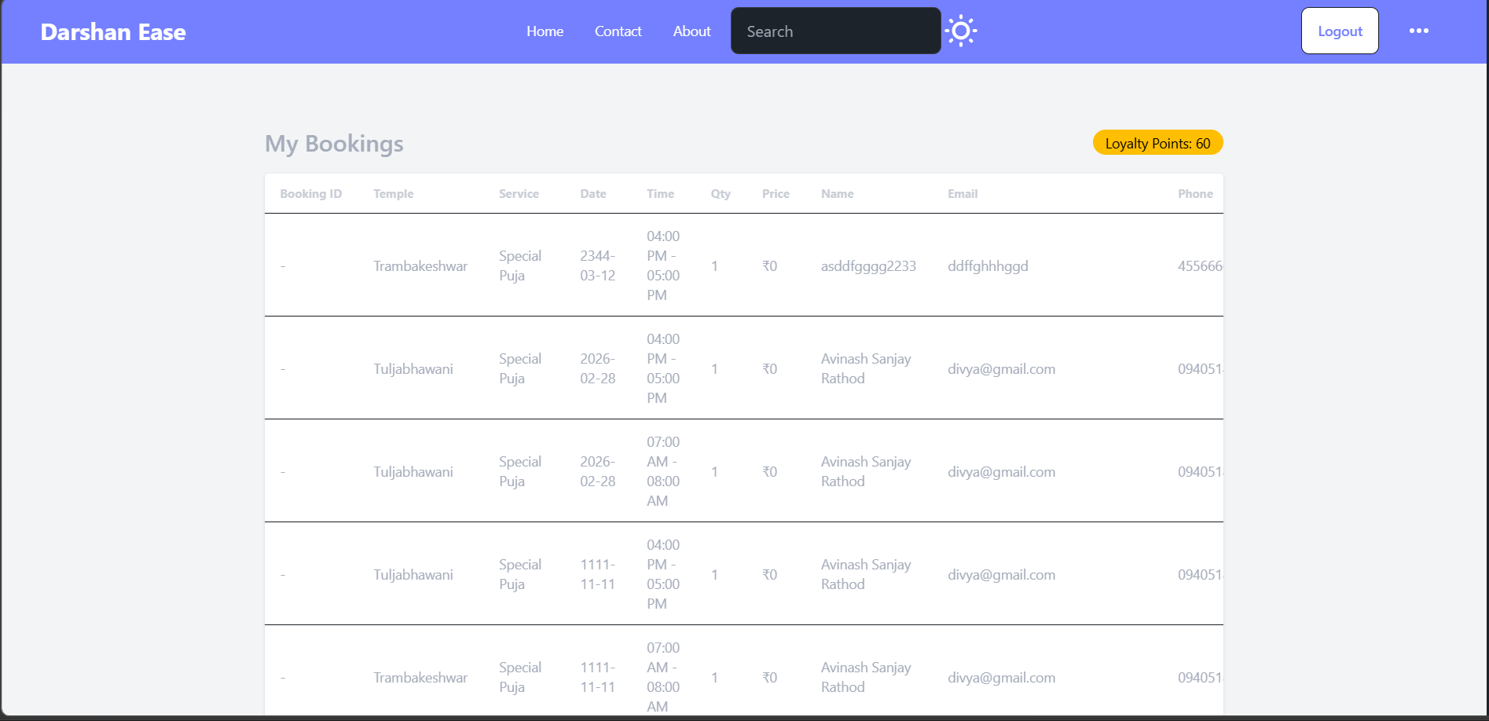
 | Tune the Model | Grid Search Validation Method: Cross Validation

